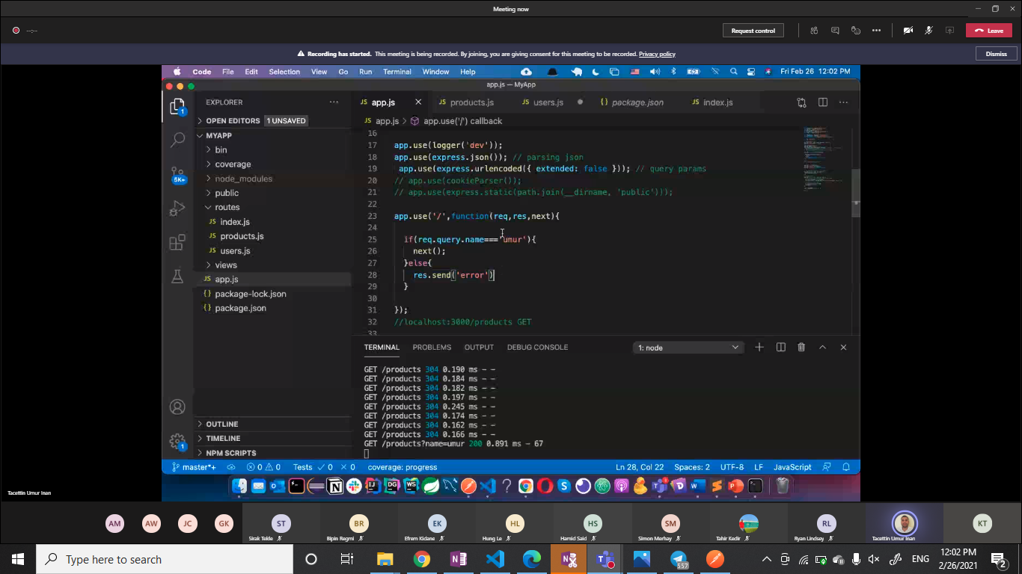

Node.js is an open-source, cross-platform, back-end JavaScript runtime environment that runs on the V8 engine and executes JavaScript code outside a web browser

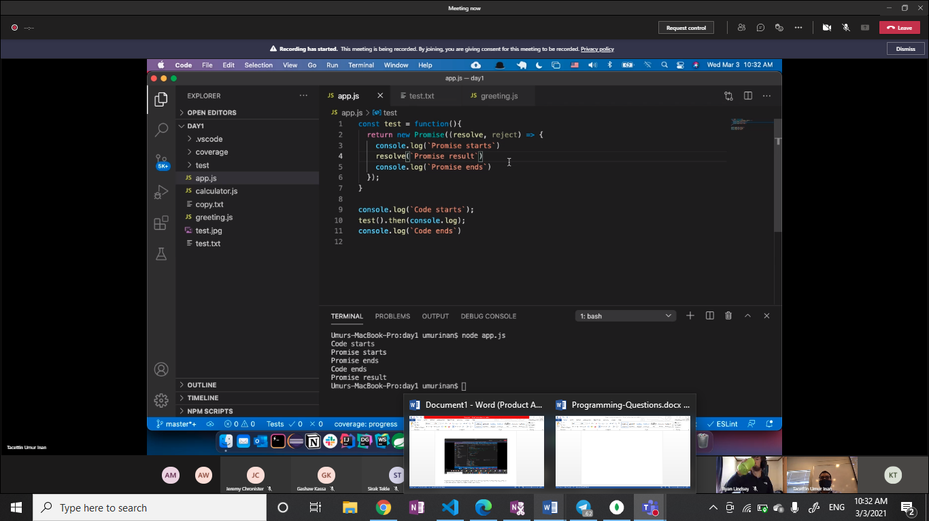

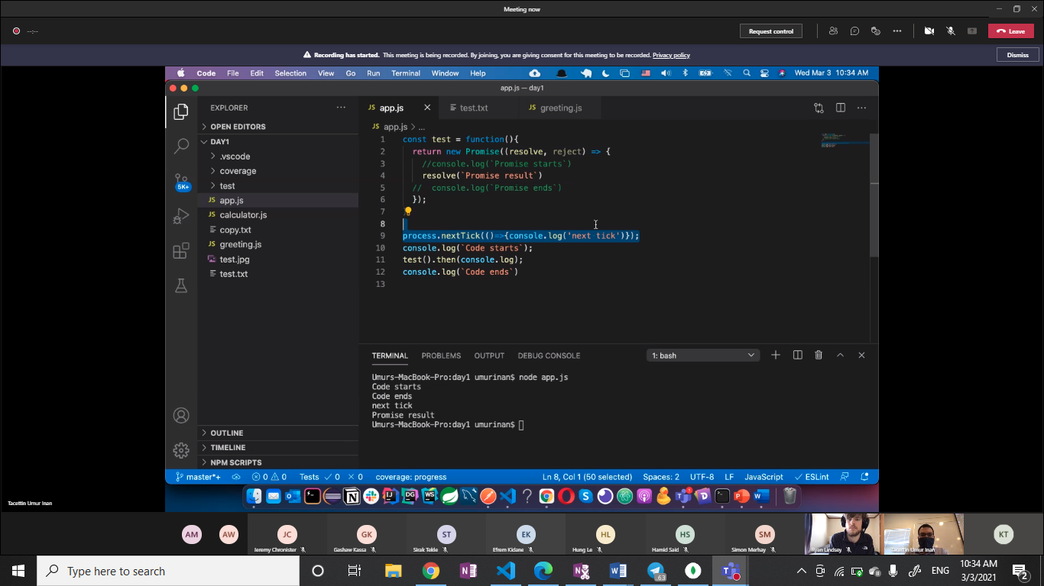

Steps to follow to connect node express with mongo db

==create empty folder

== express new foldernae

==cd to new folder

==npm init

==npm install mongodb

==

Mongo db databse command s

Show dbs //list all available databse

Use name //swiths to specific databse

Show collections // list all available tebalse

Use name_of_table // switch to speciif table

Db.tablename.find()//display all data inside the table

db.testCol.insert({"name": "Josh"})/creating new table or inserting data

// return one document with all fields db.collection.findOne({})

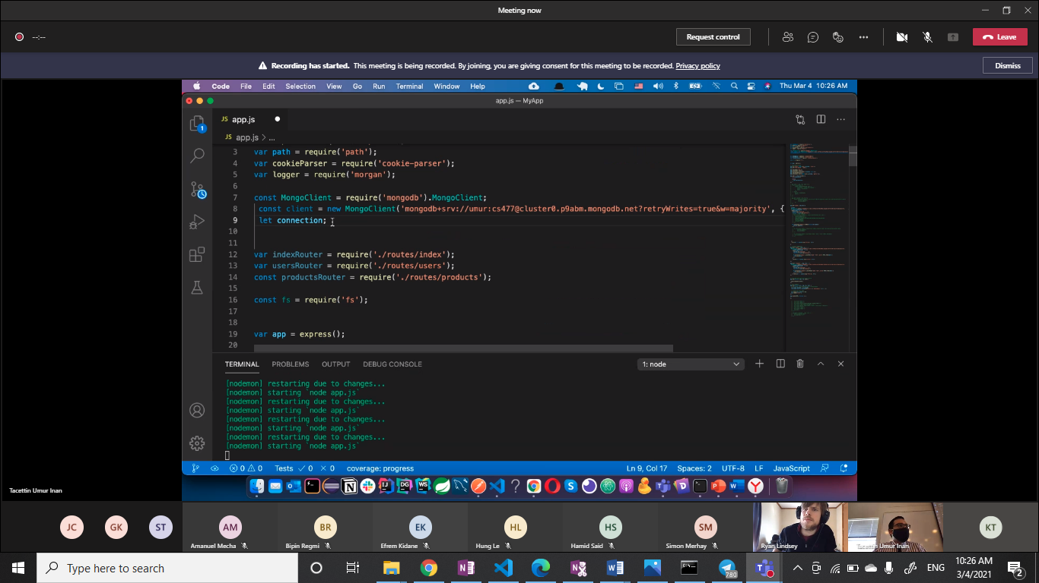

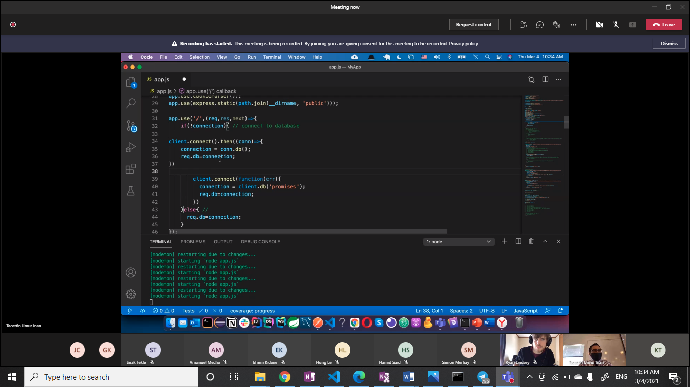

mongoimport --db lab6 --collection restaurant --file C:\Users\kas\Documents\MSD_File_COLLECTION\CS477 - NODE.JS\MyNodeclassCourse\Assignement\ restaurants.json –jsonArray

gswit :

mongoimport --host sandbox-shard-00-01.lgbrt.mongodb.net:27017 –db lab6

--type json --file C:\Users\kas\Documents\MSD_File_COLLECTION\CS477 - NODE.JS\MyNodeclassCourse\Assignement\ restaurants.json --jsonArray –authenticationDatabase admin –ssl --username m001-student --password 2300